# Source code on GitHub:

<https://github.com/Ciupe/University/tree/main/Semestrul%205/FLCD/Lab%204>

# fa.in:

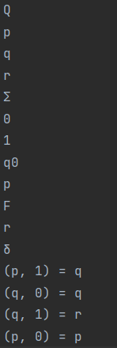

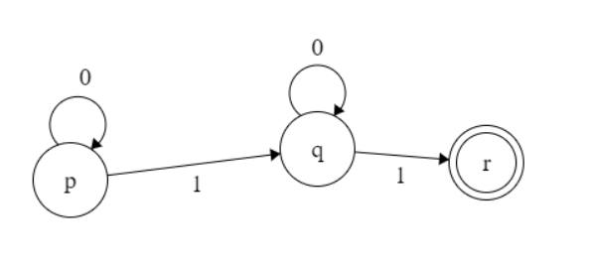

# Finite Automata implementation:

## Structure:

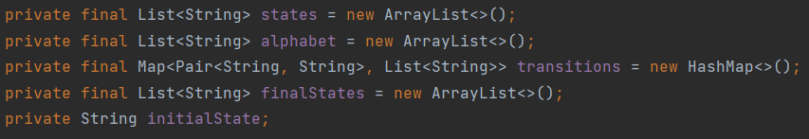

## DFA check:

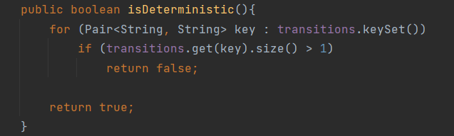

* Iterates through all transitions and returns fale if one state has more than 1 destination

## Sequence check:

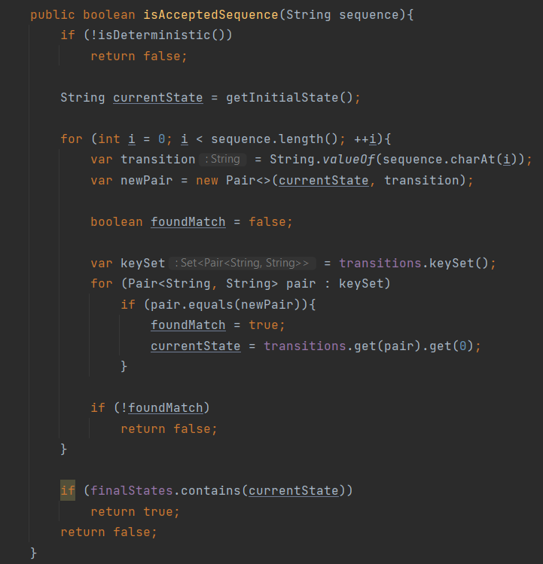

* Returns false if our FA is not deterministic or if there is no accepted route from our current state to another state or if the last state is not in the set of final states